CN ASSIGNMENT 1

To capture live network packets using Wireshark and identify basic network protocols such as TCP, UDP, IP, and DNS.

Step 1: Launch Wireshark
  - Open Wireshark
  - You will see a list of network interfaces
    - Wi-Fi
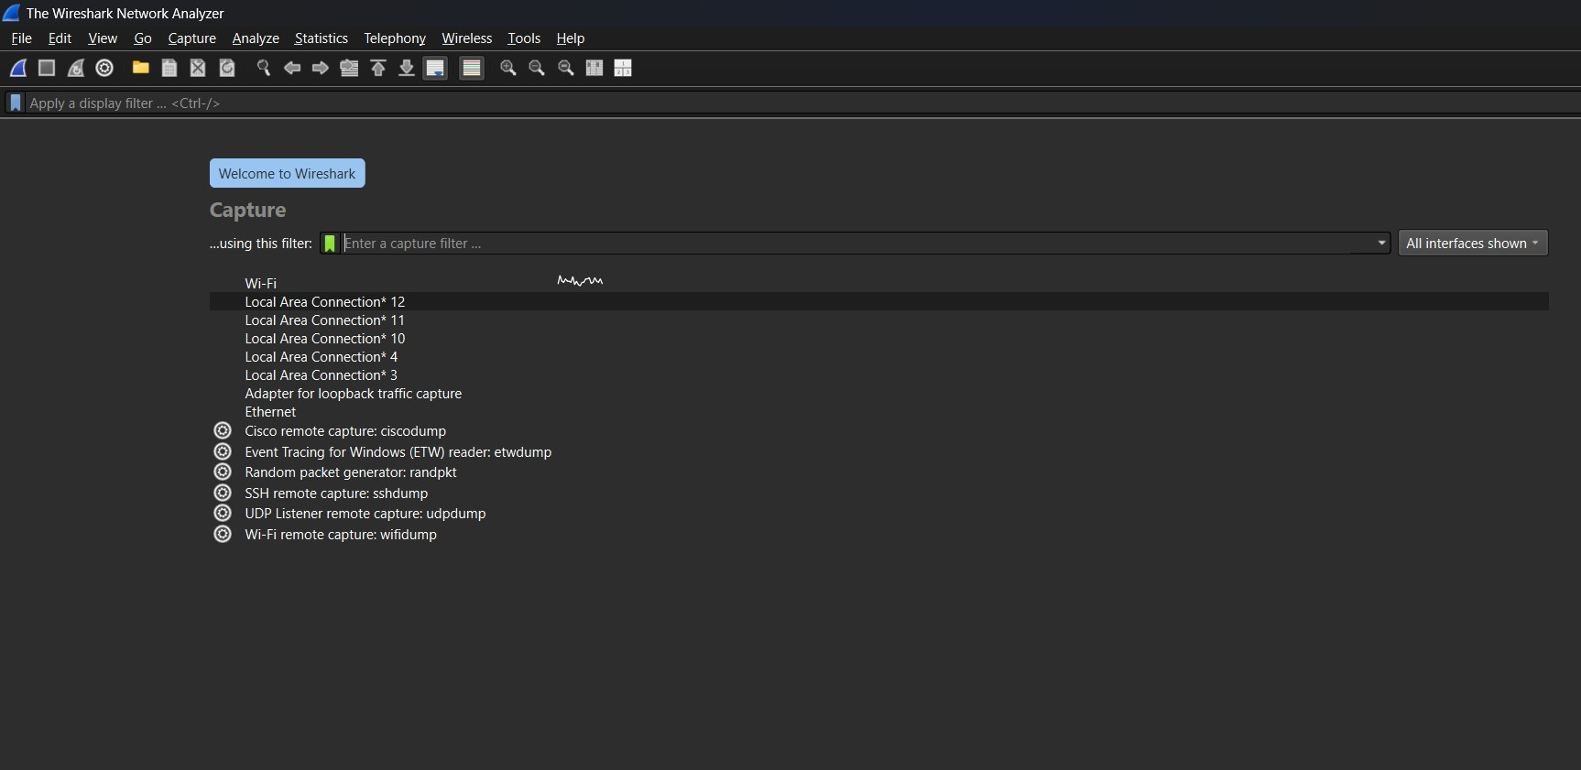
    - Ethernet

Step 2: Start Packet Capture
  - Double-click on Wi-Fi (or active interface)
  - Packet capture will start immediately

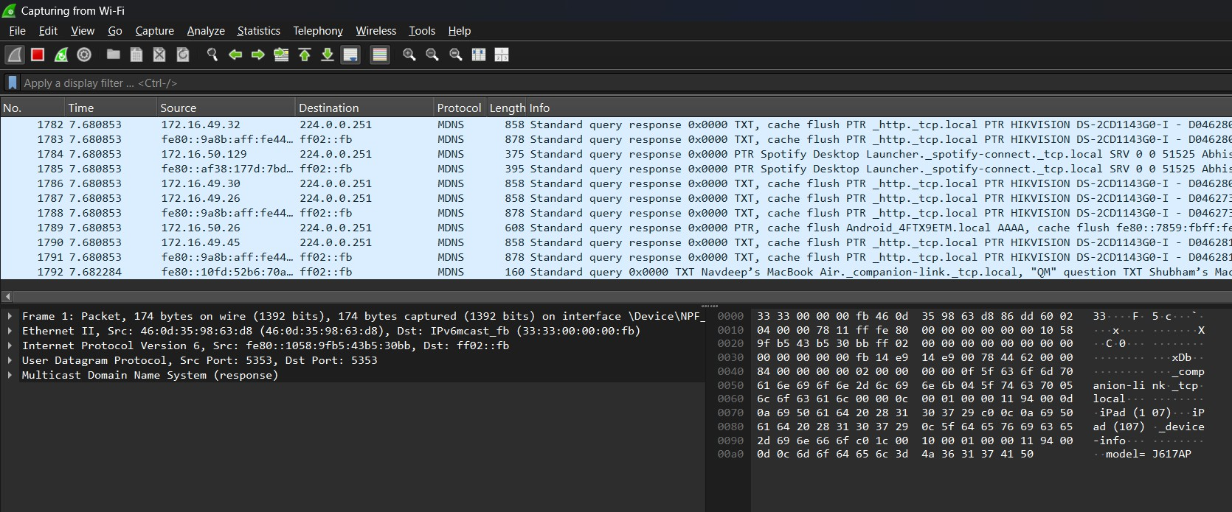

Step 3: Generate Network Traffic
Perform any of the following:
  - Open a web browser
  - Visit any website (e.g., google.com)
  - Open Command Prompt and run:
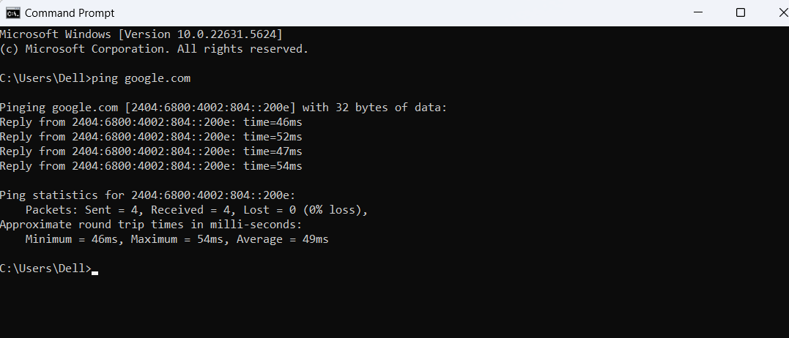
  - ping google.com

Step 4: Stop Capture
  - Click the red Stop button
  - Captured packets will remain on the screen

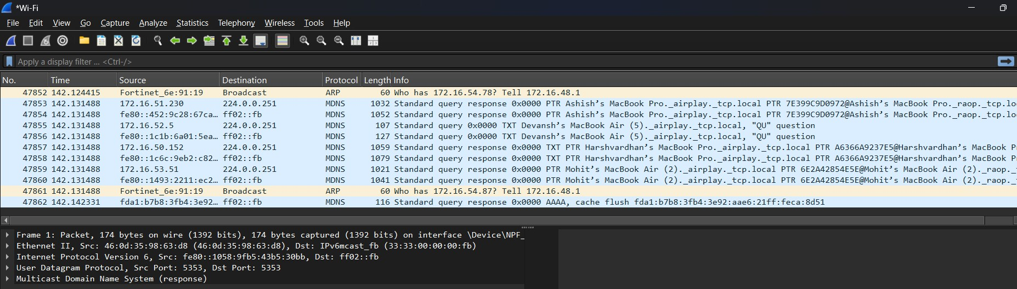

Step 5: Apply Basic Filters
Use the Display Filter bar:

Filter Purpose
ip Show IP packets
tcp Show TCP packets
udp Show UDP packets
dns Show DNS packets
icmp Show ping packets

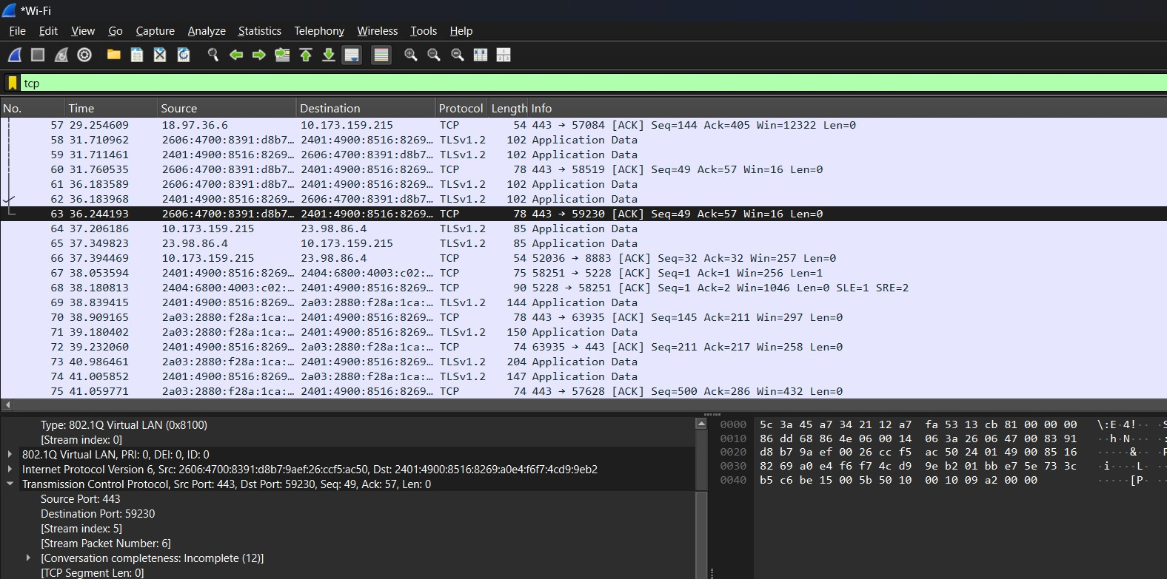
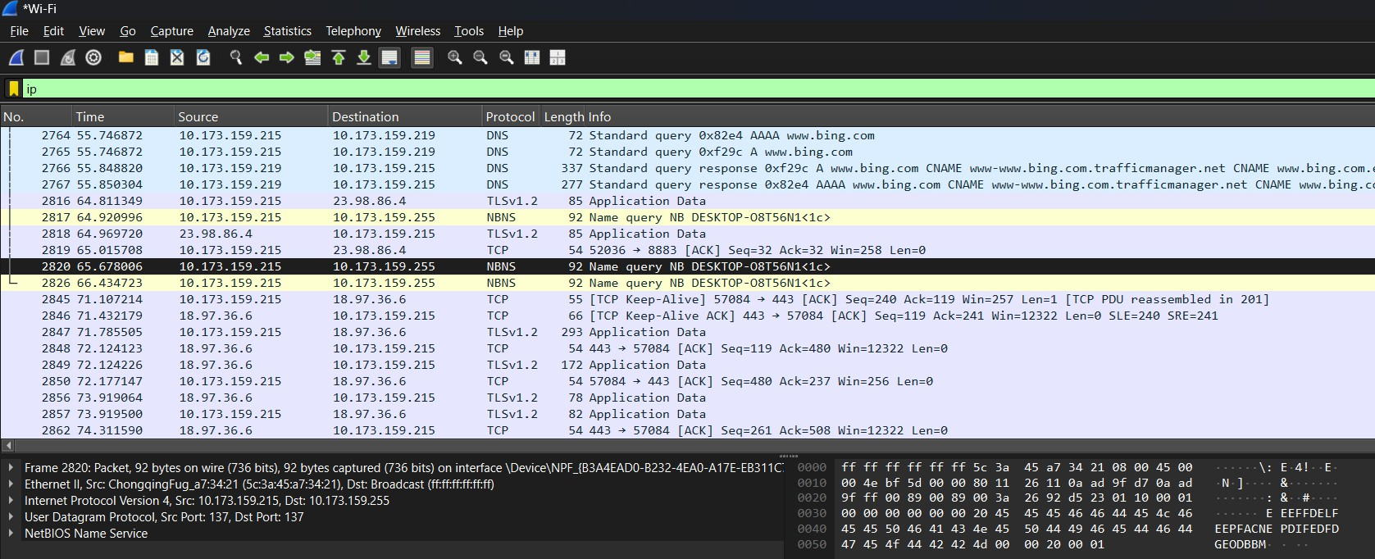

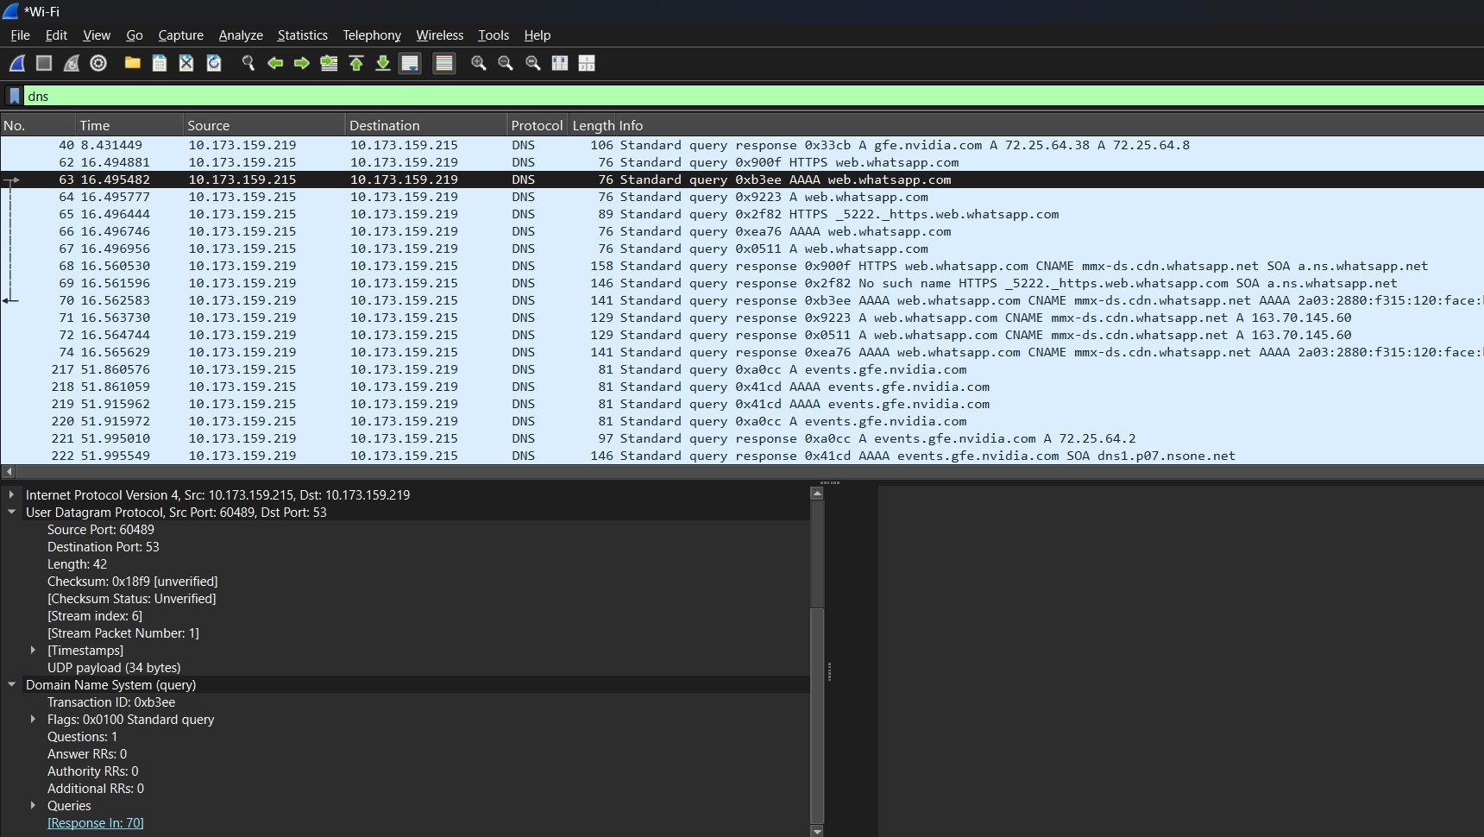
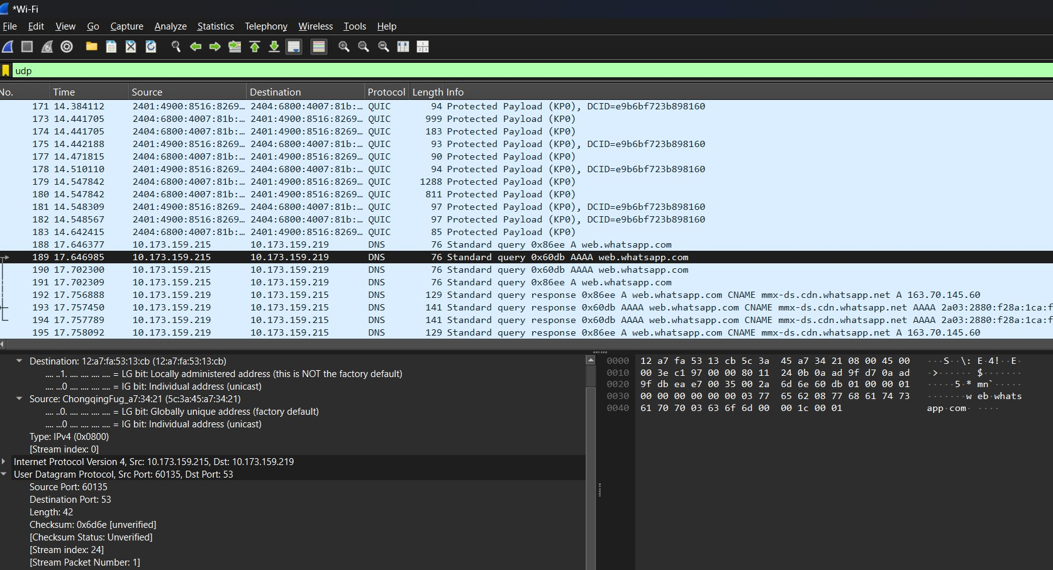

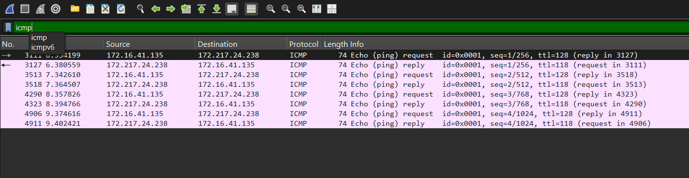

Step 6: Analyze a Packet
- Click on any packet
- Observe:
  - Ethernet header
  - IP header
  - TCP/UDP header
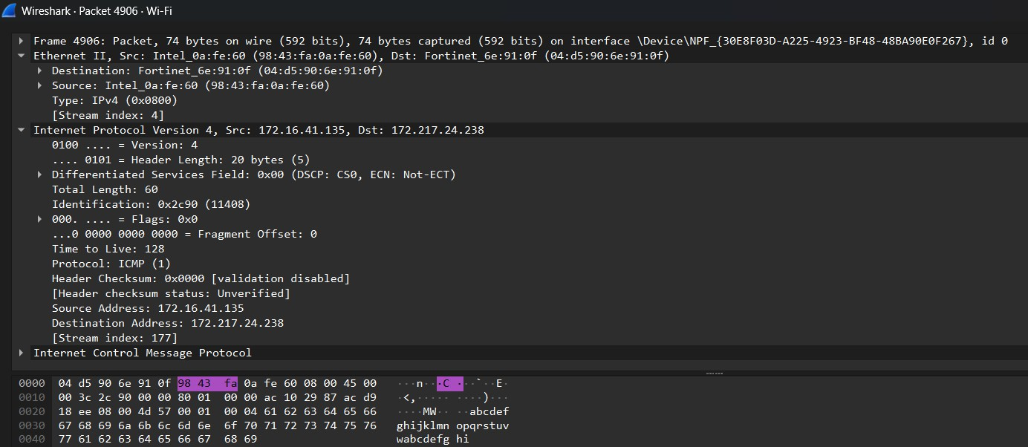
  - Payload data

